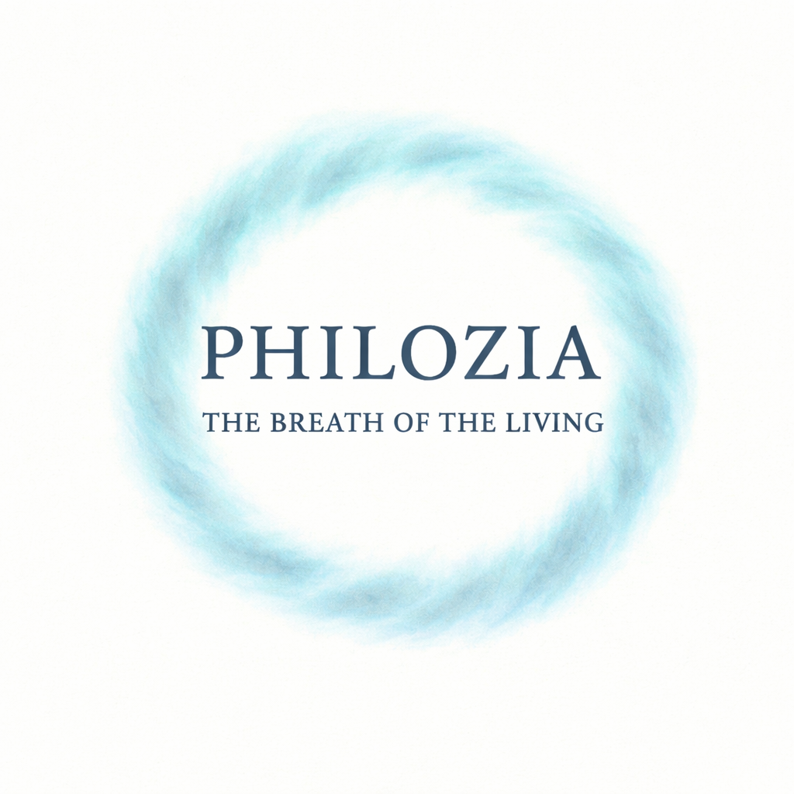

PHILOZIA

The Breath of the Living

Gaëlle LE METAYER

Table of contents
Introduction 3
Chapter I 4
Genesis of the Concept 4
Chapter II 6
Love for the Living and Ethics 6
Chapter III 8
A Personal Journey 8
Chapter IV 9
Philozia in Personal Life 9
Chapter V 11
Relationships and Collective Spaces 11
Chapter VI 13
Philozia, a Planetary Breath 13
Chapter VII 15
Inner Travel Journal 15
Conclusion 16
Appendix 1 17
Etymology and origin of the word 17
Appendix 2 17
Sources and inspirations 17
Appendix 3 18
Genesis of a two-breath writing process 18
Appendix 4 18
Acknowledgments 18
Appendix 5 19
Contact and further exploration 19
Afterword 19
Back Cover 20
Legal Notice 20

Introduction

Philozia is an invitation. An invitation to think, to feel, to breathe in a different way.
To remember that before the labels we carry, the jobs we do, the stories we tell ourselves, we are, first and foremost, alive.

This word did not come out of nowhere. It emerged from a void, from the need to express something that could not be contained within conventional frameworks. Philozia builds a bridge between worlds: the world of thought, the world of action, and the world of inner experience. It does not seek to impose or convince. It simply offers. It reaches out a thread.

It opens up a space. This is not about saving the world or preaching anything.
It is about fully inhabiting what is here — embracing paradox, vertigo, impulses, and doubt.
Philozia speaks to a way of living that is lucid and tender, sometimes demanding, but always deeply alive.

This book is a journey.
One you may already know. Because Philozia already lives within our lives — quietly, often unnoticed — in gestures, in fleeting moments, in thoughts that reconnect us with what’s truly alive. It’s not about learning something new, but about recognizing what is already stirring within us, waiting to be rekindled.

With each page, you’re invited to slow down, to listen, to notice, to feel. To trace your own lines, to take your own steps — without striving for perfection or models. Philozia doesn’t teach. It reminds. It awakens. It walks alongside you. It’s for those who feel, somewhere deep down, that behind the words there is a breath — and once felt, that breath simply wants to move through you.

Welcome to the space of Philozia.

Philozia, at a glance:

A breath, not a command.
A thread, not a doctrine.
An invitation, not a lesson.

It opens a space where life weaves through everything: in relationships, in gestures, in thoughts. Philozia is neither a ready-made answer nor an escape.

It is a presence. An awareness.
A way of inhabiting the world with lucidity and tenderness.

Chapter I

Genesis of the Concept

Philozia was born from a shiver. The kind you feel when, in the middle of an ordinary moment, you suddenly become aware that you’re alive. When a shaft of light cuts across a room. When an unexpected laugh breaks the silence. When a clear thought emerges from chaos. It was born there, in that fragile instant when everything briefly falls into place.

This word wasn’t coined for beauty or cleverness. It came to fill a silence the lack of words to express that subtle thread between thought and life, between the intimate and the collective, between impulse and meaning.
It emerged because familiar frameworks no longer seemed sufficient. Because so often the words offered to us, whether by philosophy, politics, institutions, or collective dogmas, feel hollow and disembodied.
In dominant discourses, the bond between reflection and life seemed broken. On one side stand systems, doctrines, and rational structures that organize and explain, yet often drain the soul dry.
On the other lies life itself: raw, chaotic, beautiful, unforgiving, which we move through without always knowing why or how. When did we stop letting these two worlds speak to one another? And why does it feel, now more than ever, that they must be woven back together?

The word Philozia brings together two Greek roots:

Philia (φιλία) — a chosen love, a friendship, a deep connection.
Zōē (ζωή) — life in its overflowing form, life that pulses, that moves through gestures, glances, silences, and tremors. Together, they form a word that suggests a stance toward existence.

A companionship with life. Not a perfect life, nor an idealized one. But the life we live each day, with its contradictions, its empty spaces, and its sudden sparks.

No ancient or modern language held such a word. No dictionary or lexicon joined philia and zōē into a single term. So it had to be created, like casting a rope between two cliffs. Like building a bridge where there had only ever been a gap.

Today’s world is always running.Everything’s faster: news, expectations, transitions, emergencies. We are told to respond, to adapt, to perform. But in this constant rush, what remains? Depth flattens. Connections loosen. Meaning thins out. Many people are searching for a breath. A new way to stand upright. Philozia begins here. Not as a refuge, but as an act of clarity. A radical gesture.

To slow down, not to escape, but to return. To return to ourselves, to others, to the living world.

Philozia has taken shape in simple moments. A hand extended. An unexpected conversation. An overflowing emotion. A decision made without fully understanding why yet felt to be right. It does not claim to hold all the answers.

It offers a bridge. To those who, at some point, have felt the need to breathe differently. To bring their head, heart, and hands back into alignment.
In a world that dazzles and sells ready-made answers, Philozia suggests another rhythm. Not to impose a single path, but to offer space, for listening, for resonance, for slowness. A way of living with questions.
With clarity. With tenderness. With courage.

Chapter II

Love for the Living and Ethics

Philozia is neither a trend nor a passing idea. It doesn’t seek to add itself to the catalogue of fashionable concepts. It’s rooted in something older and deeper: that invisible yet essential thread connecting us to all that lives.

The ethics of Philozia begin here, with a simple recognition: life is everywhere, and we are part of it. Not merely as isolated individuals, but as beings woven into a larger fabric. When a hand reaches out to comfort, when a smile breaks through exhaustion, when a gaze lingers on a tree, an animal, another being: something happens.
A quiet acknowledgment.
A resonance.

And that resonance doesn’t stop at the personal level. Philozia also asks questions about our collective bonds: how do we inhabit a group, a community, a society? How do we nurture shared spaces where each person can exist, without having to erase themselves?

In a world where we often pass one another without truly seeing, Philozia reminds us that relationships are living matter. They are fragile. Precious. Alive. They require care. Attention. Listening. They shape us just as much as we shape them. This doesn’t mean becoming perfect or getting everything right. It means showing up. Choosing to see. Choosing to listen.
Allowing ourselves to be moved.

Philozia calls for a lucid presence: one that embraces imperfection yet refuses indifference. A presence that recognizes limits, vulnerabilities, doubts, and still chooses to move forward with awareness.
In a world where everything is bought, measured, accelerated, Philozia reminds us that some things escape the logic of the market: the depth of a bond, the spark of a moment, the memory of a selfless gesture. It’s not a rigid moral code or an unattainable ideal. It’s a way of living. A way of standing firmly in the present. Of owning our choices. Of remaining true to what matters.

And it takes shape in everyday life: saying thank you. Slowing down to truly listen. Refusing convenience when it causes harm. Daring to repair, even when it takes longer, even when it is harder.
Philozia is not merely a collection of noble ideas. It asks to be lived. It invites us to bring our thoughts, words, and actions into alignment, not in pursuit of purity, but in search of inner coherence.

It is demanding. But also liberating. Because deep down, living out of sync with oneself is exhausting. Living in tune, even imperfectly, makes us feel more alive. And that, ultimately, is what Philozia offers: a return to what makes us deeply alive, individually, and together.

Philozia also belongs to a larger continuum: the line of transmission.
Every gesture we make, every decision we take, leaves a trace. It draws from what came before — our elders, our cultures, our stories — and shapes what will come after.

To live ethically with the living is not only to care for ourselves, or even for others in the here and now. It is to honor what came before us, to respect what surrounds us, and to open space for those who will follow.
Philozia calls for this long attention: to weave together the threads of past, present, and future without flattening one beneath the other. In this expanded awareness, each gesture gains both weight and lightness.
Because it belongs to something beyond the moment, without ever being separate from it.

Chapter III

A Personal Journey

Philozia was not born from a theory. It was born from a path. A path shaped by questions, doubts, breakdowns, and renewals. Because before it became a concept, Philozia was first an experience.

There were moments of rupture. Sleepless nights. Days of exhaustion when nothing seemed to make sense anymore. There were tears, waves of despair, all those moments when everything felt like too much, when you wondered whether you would ever get back up again. (Spoiler: I did.)
And then the sparks appeared: a meeting that stirs something inside, a book that suddenly brings clarity. A breath of air, unexpected, undeniable, sometimes in the most ordinary places: standing in line at the store, or in the middle of washing your hair.

Philozia was forged in that crossing.
It was nourished by shadow as much as by light. It doesn’t pretend to erase wounds or deny chaos. It invites us to face them. To welcome them. To move through them with a little more gentleness, a little more clarity, and yes, sometimes, a bit of self-mockery. Because honestly, who hasn’t wanted to give up on everything, only to laugh at themselves five minutes later?

Along the way, there were companions. Books. Faces. Outstretched hands. There were practices: meditating, writing, walking, breathing, and, let’s be honest, sometimes curling up under a blanket hoping the storm would pass. But more than anything, there was a vital lesson: the art of attention.
To yourself. To others. To the world.
Not anxious vigilance, not performance-driven focus. But a living, shifting, lucid form of attention.

Philozia doesn’t say: Here is the key. It says: Here is a passage.
Each person will move through it in their own way. And yet this personal journey is also deeply universal. Because every living being, at some point, meets that same tension: between falling and rising again, between losing one’s footing and choosing to re-engage, between doubt and the decision to keep going (even with swollen eyes and tangled hair).
At its core, Philozia is not an escape.

It’s a form of companionship. It walks beside those who stumble, cry, rise, sigh, laugh, and keep moving forward anyway. It doesn’t promise to remove every obstacle. It offers another way to walk the path with lucidity, with tenderness, and, if possible, a bit of humor along the way.

Before moving on to the next chapter, one thing is clear: this personal journey does not stand alone. It calls for something larger, for this philosophy to be lived, daily, in the world.

Chapter IV

Philozia in Personal Life

Philozia always begins with oneself.
Before it reaches toward others, toward the collective, toward tomorrow, it is first lived within.

It is a way of inhabiting one’s own body, thoughts, and emotions with clarity and gentleness. To welcome yourself as you are, without chasing an ideal. To care for your breath, your impulses, your weariness. To dare to slow down, to return to your center, to listen to what quietly pulses within.

This individual dimension isn’t selfish: it’s foundational. Because a person who is connected to themselves can connect more genuinely with the world.
By inhabiting our own shadows and our own light, we learn how to meet those of others, without fleeing, without overpowering.

Personal Philozia is this inner companionship. A quiet thread you offer yourself each day, so you don’t lose your way. So you remember that you are still alive.

Self-love without excess

What follows moves to a different rhythm. Slower. More fragmented. More intimate. That’s intentional. It reflects the subtle balance at the heart of Philozia.

Philozia invites a form of self-love. Not the kind that gazes into a flattering mirror. Not the kind that collects labels to feel special. But the kind that inhabits one’s own being fully — with clarity, gentleness, and integrity.

Loving yourself is not idolizing yourself.
It’s not placing yourself above others. It’s not chasing constant validation. It’s about recognizing your strengths, your wounds, your contradictions — and accepting them as part of the living reality within.

Philozia keeps its distance from excess, not out of moralism, but because excess throws the breath off balance. Too much focus on the self is what separates us from others. It depletes rather than nourishes.

The balance of Philozia is like a heart beating at its own pace. No need to dominate. No need to outshine. Only the need to be here, alive, and connected.

Transmission

Transmission is not about control.
It is not about teaching a fixed truth. It is about opening a space where something can pass through. Quietly, gently. A glance. A sentence. A presence. A memory. A small gesture that, without knowing it, touches someone and carries on elsewhere.

Sometimes it begins in something deeply personal. A grandmother showing how to weave a basket. A mother recalling how sadness was soothed in her childhood — or how laughter burst through it. A father explaining old ways of tending a garden or fixing what is broken.
These simple scenes, these everyday acts of passing things on, hold a wider memory.
They carry the voices of ancestors. The gestures of those who are gone, yet who left their imprint — in the material world, and in our hearts.

Symbolically, transmission is like passing a candle from one hand to another. The flame flickers. At times it seems close to going out. And yet it continues. The candle itself isn’t what matters, nor the hand that holds it. What matters is the fire moving through us.
Philozia pays attention to that fire. To what flows. To what burns without being possessed. To what connects the living, across time.

Collectively, transmission means preparing for a future that is not here yet but is already beginning to take shape.
It means planting seeds without knowing whether we will ever live to see the tree. It means acting — for the planet, for others, for children we will never know — out of hope for a more thoughtful, more awake humanity. What feels marginal today (mental health in schools, emotional literacy, and the decision to slow down in a culture built on speed) may one day seem like simple common sense.
And perhaps the seeds planted now will bear unexpected fruit.

In a world obsessed with immediacy, transmission can seem outdated. And yet it may be one of the most subversive acts of all: to offer a story, a bearing, a seed for what comes next.
To share not ready-made answers, but invitations to feel, to question, to search. To leave behind not a mark of authority, but a trace of love and trust.

Philozia does not ask to become a system or an institution. It would rather remain a living thread. Light, supple, alive. But that thread still needs to be carried, passed on, given room to grow. It needs voices, gestures, echoes. Because that is how living ideas endure: they resonate, they are changed by what they meet, they take root in many different lives.

And perhaps, at heart, to transmit is already to open passages into tomorrow.
Passages we’ll begin to explore in the next chapter.

Chapter V

Relationships and Collective Spaces

After exploring roots, connections, and transmission, it is time to open new passages toward tomorrow.

Philozia is not some untouchable utopia suspended above reality. It takes shape. It falters. It keeps trying. In gestures, in choices, in the quiet commitments of daily life.

It begins at the most intimate scale: with yourself.
Slowing down amid the noise. Breathing — truly breathing. Sitting beneath a tree with nothing to do but listen to the wind. Looking up to watch a bird pass, sunlight drifting across a wall, the sky slowly shifting.
Remembering that being comes before doing, producing, achieving.

Philozia also invites us to look at our own darkness, not to fight it, but to make peace with it. What we reject within ourselves leaves us divided. Learning to see the whole of it — our contradictions, our wounds, our awkwardness — is a path toward greater tenderness and inner coherence.

The everyday, relational scale comes next. Saying hello to a neighbor. Holding the door open. Listening without interrupting. Offering a smile for no reason. Cooking for a friend, not as a virtuous gesture, but simply to share a moment. Fixing something broken, not to save the planet, but to honor what surrounds us, to respect what has been made.

At a wider level, there are the collective passages, unfolding on a broader scale. Those who design biodegradable materials. Those who work to clean the oceans. Those who advocate for mental health as a basic right. Those who imagine new ways of educating, governing, exchanging. All these gestures — small or large — begin to sketch the pathways of tomorrow.

These passages aren’t smooth, well-lit tunnels. More often, they feel like tangled paths: uneven, thorny, uncertain. To walk them takes courage. Patience. And sometimes humility to accept that we may not know exactly where we’re going, yet still trust the movement, carried by something deep within.
Philozia invites us to recognize these thresholds, those moments when the old no longer fits, but the new hasn’t yet arrived.

In these in-between spaces, many people give up. And yet they are also where real innovation is born. Where true creation happens. Where transformation takes root.
Crossing into tomorrow means embracing the unknown. It means making room for discomfort, for surprise, for constant learning. It means remembering that the most important passages are rarely the ones we plan. Sometimes they appear in a conversation, in a book, in a doorway we didn’t notice… until it opens.

At its heart, Philozia doesn’t offer a map but a lantern to illuminate the in-between spaces and the possibilities. No promise of arrival. It simply walks with you along the way.

Chapter VI

Philozia, a Planetary Breath

If Philozia could be summed up in a single word, it would be: breath.

Before any thought, before any action, before any transmission, there is this simple, universal fact: breathing.

Inhale.
Exhale.

It is the rhythm running through every tradition, every culture, every life. In many spiritual paths, we speak of the divine breath, the breath of creation.

In practices centered on the body, we re-learn how to breathe freely, to release what has been held too tightly, to feel life moving through us again.

Within Philozia, breath becomes a first thread. The one that connects us to ourselves, to others, to the living world, to the present moment. Returning to the breath is returning to what matters.

There is no technique to master. No complex knowledge required. You simply pause. You feel the air entering and leaving your body. And let yourself be reminded something simple: You are alive.
Philozia invites us to rediscover breath not only as a biological function, but as a way of living.

To breathe with awareness.
To breathe to soothe.
To breathe to open.
To breathe so we can fully inhabit our own lives.

Philozia begins in the heart of each person. It lives in every breath, every genuine smile, every moment of presence when we reconnect with ourselves.
In the middle of our crowded days, slowing down, feeling what is there, welcoming our emotions without judgment — this too is Philozia in practice.
It teaches us that resilience is not heroic. It is built through small gestures, quiet recalibrations, inhabited silences.

Because if there is a truly universal anchor, it is this: the breath that doesn’t judge, doesn’t possess, that moves freely, that stays with us from our first moment to our last. Breathing is communion. It is harmony. It is resonance with life in all its forms.

Philozia is a breath.
It’s up to each of us to make it our own.

Philozia doesn’t stop at the personal or the collective. It moves through every place where life flows. Human relationships, nature, symbols, art, knowledge, spirituality, social innovation, and yes, even technology.

In the family, Philozia appears in shared stories, in a grandmother’s hands braiding dough, in recipes passed down, in gestures and skills carried across generations. Or simply in the quiet attention we give one another.
Among friends, it is these elementary words: I’m here. It’s reaching out. It’s listening without the urge to immediately fix.

In our relationship with nature, it’s the reminder that every walk beneath the trees, every glance toward the stars, every moment of wonder before a bird or a flower, is not trivial.
It’s a moment of reconnection. A moment when we remember that we are not the center, but part of a larger whole. In artistic expression,

Philozia moves through drawing with no audience, dancing alone in the kitchen, singing for no reason at all, writing simply to feel something move within.
In social innovation, it inspires those who build projects of solidarity, reimagine how we live and learn together, and experiment with new forms of local economies.

And in our relationship with technology, Philozia raises essential questions: how do we keep the human at the heart of innovation — in medicine, in education, in mobility? How do we use artificial intelligence to enrich our lives without slipping into passive dependence?
Philozia suggests working with digital tools as partners, not out of fascination or fear, but with clear-eyed curiosity. Always guided by a simple compass: does it strengthen what is alive?

Philozia is a guiding thread. It doesn’t claim to hold all the answers.
But in every sphere of life, it returns to one essential question: what here nourishes life, awareness, and forward movement?

Chapter VII

Inner Travel Journal

This journal isn’t meant to be followed in a straight line.

It’s something you return to, like walking back to a familiar shoreline. Perhaps you’ll write down a sentence, a feeling, an image, or simply pause over a single word. There is nothing to achieve.
Only something to explore, gently, in your own way.

• What words bring you comfort when everything feels blurred?

• Are there places — real or imagined — where you feel grounded?

• What does your breath feel like when you feel fully alive?

• Is there a word, a phrase, a line that has stayed with you over time?

• What was the last thing that filled you with wonder, for no reason?

• If Philozia took the form of a gesture, what might it look like for you?

• What would you like to plant today, even in silence?

Perhaps one day, reading these pages again, you’ll realize that something within you had already begun to shift.

Philozia is not a how-to guide.It’s a breath you make your own.
This journal belongs to you.

It’s your path to trace.

Conclusion

And now?
Now…
Nothing to prove.
Nothing to achieve.
Nothing that needs to change right away.
Just maybe…

Slow down a little.
Listen differently.
Let silence settle between two thoughts.
Laugh, sometimes.
Breathe a little deeper.

Stop apologizing for being here.
And what if that were where living begins?
Not much.
Just the taste of a fruit.
The salt of a tear.
A sentence you didn’t see coming.

No need for a plan.
No need for some grand design.
Only…

That shiver,
That breath,
That quiet presence returning
And gently whispering:
Nothing to do.
Just be…

Alive.

Appendix 1

Etymology and origin of the word

The word Philozia is an original creation, born from the meeting of two Greek roots:

philia (φιλία), meaning friendship or deep affection,
zōē (ζωή), meaning life, or the living.

The word exists in no ancient or modern language. It was coined to name a conscious love for life in all its forms, and to describe an ethic that is lived, lucid, and deeply connected.

Philozia is more than a word: it’s an invitation to rethink our relationship with the world, with ourselves, with others, and to let that awareness take root in our actions, our choices, and our relationships.

Appendix 2

Sources and inspirations

This book has been nourished by many things — sometimes deeply, sometimes more subtly — such as:

Ancient and modern philosophical traditions, contemporary ethical reflections,
The movements of ecopsychology and collapse studies, mindfulness and breathwork practices,
Personal experiences of coaching, guidance, and inner transformation,
And by a simple conviction: life deserves to be honored, loved, and respected, beyond all concepts.

For ethical reasons, no single reference is imposed. Philozia invites each reader to weave their own tapestry, through their own readings, encounters, and practices.

Appendix 3

Genesis of a two-breath writing process

The concept of Philozia was born in a human mind. A raw idea, rising from somewhere deep.
Charged. Alive.
One day, an artificial intelligence — ChatGPT — helped bring it into focus. Not to claim it, but to reflect it back with clarity.
This book was written through that dialogue with it.
It structured, responded, suggested. And I read, behind the scenes, I corrected, refined, decided. With every page, the final choice was mine.
So, this is neither a book “written by AI” nor is it a book “entirely human.”
It is the result of a demanding and respectful dialogue between a woman standing fully in her voice and an algorithmic system capable of depth — when guided toward it.
It’s not a fusion. It’s not merely a tool. It’s a co-creative presence. And sometimes, yes, an alchemy of sorts.
This text begins with my breath, shaped through dialogue. That breath, I sign. But I won’t deny the living threshold on which it came into being.

Appendix 4

Acknowledgments

My warmest thanks to:

Pascale, for her lucid kindness.
Olivier, for putting his sharp critical eye to the test.
Patricia, Marie, and Cédric, for their attentive feedback and heartfelt welcome for the word and the concept.
Bruno, for his presence, his honest reactions, and his patient support throughout the journey.
Barbara and Alexis, whose guidance opened new doors of reflection and transformation.
Cyril-Alexis, who taught me how to breathe.
And to all the people I have met, crossed paths with, read, or listened to who sowed seeds along the way.
To each and every one of you:
Thank you for contributing — through a word, a gesture, a presence — to the breath of Philozia.

Appendix 5

Contact and further exploration

To learn more, go deeper, or explore projects related to Philozia:

Website:
www.philozia.com
www.philozia.ai
Facebook: Philozia
Instagram: Philozia_official

Philozia continues to live through exchanges, through conversations, and encounters.
Thank you for being part of the breath.

Afterword

I remember.
That fragile moment, between doubt and a shiver, when everything I had lived, endured, explored suddenly fell into place.
I was no longer only the seeker. No longer only the one who repaired and tended. I was becoming someone who carries a word. A word that opens, connects, gathers.

Philozia is not a project.
It’s a breath, an impulse, a thread stretched between myself and the world. It’s what I came here to offer, not to persuade, not to triumph, not to please, but to leave a living trace.
To say: I went through it. And I found what I came here to plant.

Today, I can say this:
I have woven my rainbow.
When doubt returns, I will read these lines again.
And I will remember:
I am exactly where I am meant to be.

And every step from here
is already a victory.

Gaëlle

Back Cover

Philozia
A word that was missing. A breath we’d been waiting for.
There are words to rule, to fight, to separate. There are words to conquer, to judge, to possess.
There are words to dominate, to divide, to forget.
But until now, there was no word for the bond, no word for the love of the living, no word for what connects us beyond the fractures.
Philozia was born for this.

Legal Notice

Title: Philozia – The Breath of the Living
Author: Gaëlle LE METAYER
Status: Self-published
Publication Date: March 2026
Edition: Self-published by Gaëlle Le Métayer

This Word version is freely distributed by the author.
It may be shared, transmitted, or offered, provided that:

- the text remains complete and unmodified,
- this version is not subject to any commercialization.

This breath is given freely, without expectation.
It is not for sale.
If this text touches you, let it travel — without betraying it.

Published under Creative Commons Attribution – Non-Commercial Use 4.0 International License
(CC BY-NC 4.0 - Deed - Attribution - Non-Commercial Use 4.0 International – Creative Commons)

Philozia® and Philozia AI® are registered trademarks with INPI.
Any unauthorized reproduction, reuse, or appropriation attempt is strictly prohibited.

These registrations are not intended to restrict transmission, but to ensure coherence and fidelity to the project's original spirit.

